**Exercise 1: Project Bootstrapping**

### **Objective:** Set up a new javascript project with a README, a main application file (index.js), and a test file (index.test.js).

## **Step-by-Step Instructions**

### **Set Up Your Environment**

* 1. **Sign In to GitHub:**
     1. Open your browser, navigate to [github.com](http://github.com), and sign in (or sign up if needed).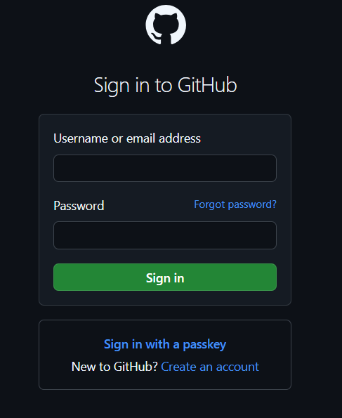
  2. **Install VS Code and GitHub Copilot Extension:**
     1. Download and install Visual Studio Code.
     2. Open VS Code.
     3. Click on the Extensions icon (or press Ctrl+Shift+X).
     4. Search for “GitHub Copilot” and click “Install.

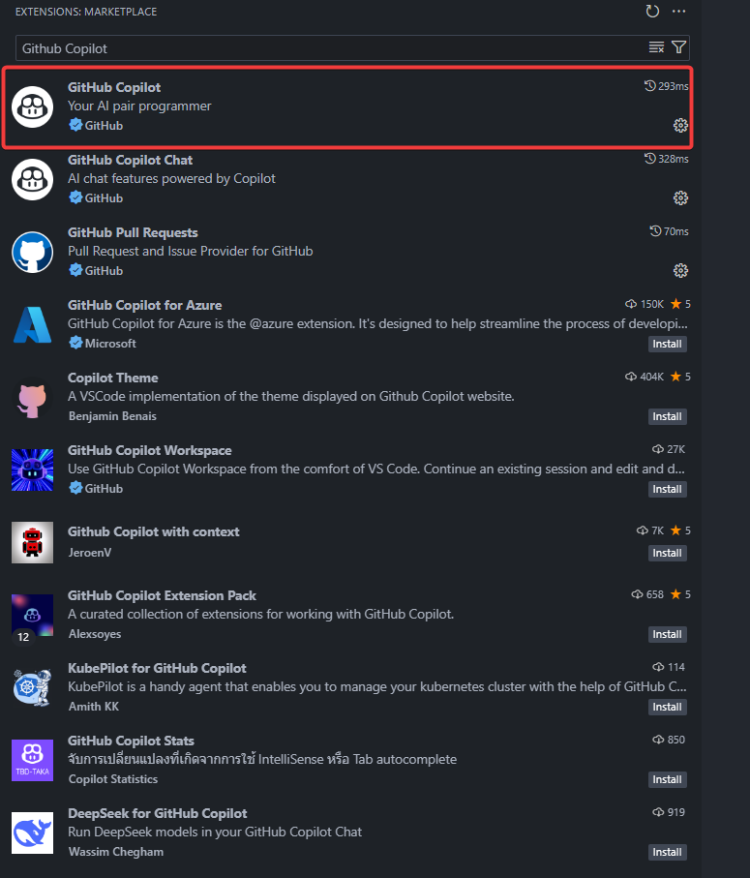

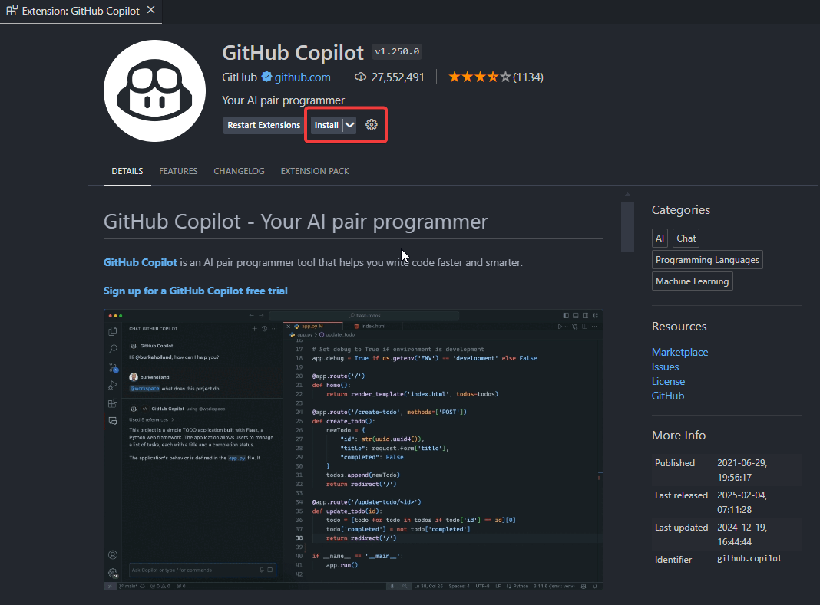

* + 1. After installation, follow the prompts to sign in to GitHub via Copilot.

### **Create a New Project Folder**

* 1. Create a folder on your computer called MyCopilotJSProject.
  2. In VS Code, click File > Open Folder… and select the folder you just created.

### **Create a README File**

* 1. In the VS Code Explorer, click “New File.”
  2. Name the file README.md.
  3. Type a comment like:

| <!-- Describe your javascript project here --> |
| --- |

* 1. If GitHub Copilot suggests a paragraph or template, press Tab to accept the suggestion.
  2. Save the file (Ctrl+S).

### **Create the Main Application File**

* 1. In your project folder, create a new file named index.js.
  2. At the top of index.js, type a comment:

| // Main application file for MyCopilotJSProject |
| --- |

* 1. Allow Copilot to show you suggestions (for example, a basic function or a “Hello, World!” snippet). Accept any helpful suggestions by pressing Tab.

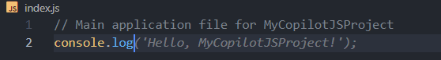

* 1. Save the file.

### **Create the Test File**

* 1. Create another file named index.test.js.
  2. Start with a comment indicating the purpose:

| # Test cases for functions in index.js |
| --- |

* 1. Type a simple comment such as:

| # Write a test for a simple greeting function |
| --- |

* 1. Watch for Copilot suggestions; if you see a recommended test function, press Tab to accept it.

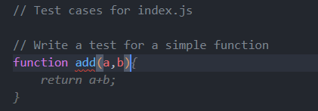

* 1. Save the file.

### **(Optional) Initialize a Git Repository**

* 1. Open the terminal in VS Code (View > Terminal or press Ctrl+`).
  2. Run the following commands:

| git init git add . git commit -m "Initial project bootstrapping for javascript" |
| --- |

### **Verify Your Setup**

* 1. Open any of your files (e.g., index.js) and start typing. GitHub Copilot should display suggestions.
  2. If not, ensure the Copilot extension is enabled and you’re signed in.

Voila!! We have successfully completed this exercise.